**Report on Energy Production Prediction using LSTM**

Preprocessing:

- Handling of missing data with forward fill.

- Feature engineering to extract useful temporal features.

Exploratory Data Analysis (EDA):

- Visualizations of yearly and monthly energy production.

- Identification of seasonal patterns and trends in energy production.

Modeling:

- Selection of LSTM architecture for time series prediction.

- Configuration of layers, including LSTM, dense, and dropout layers.

- Dataset preparation for LSTM input.

Evaluation:

- Use of Mean Absolute Error (MAE) and Mean Squared Error (MSE) for model performance assessment.

- Hyperparameter tuning for optimal model performance.

- Logging of losses during training for monitoring.

Results and Conclusion:

- Successful prediction of solar and wind energy production.

- Insights from EDA guided model design and feature selection.

- Future work suggested for refinement and enhancement of model accuracy.

**Results**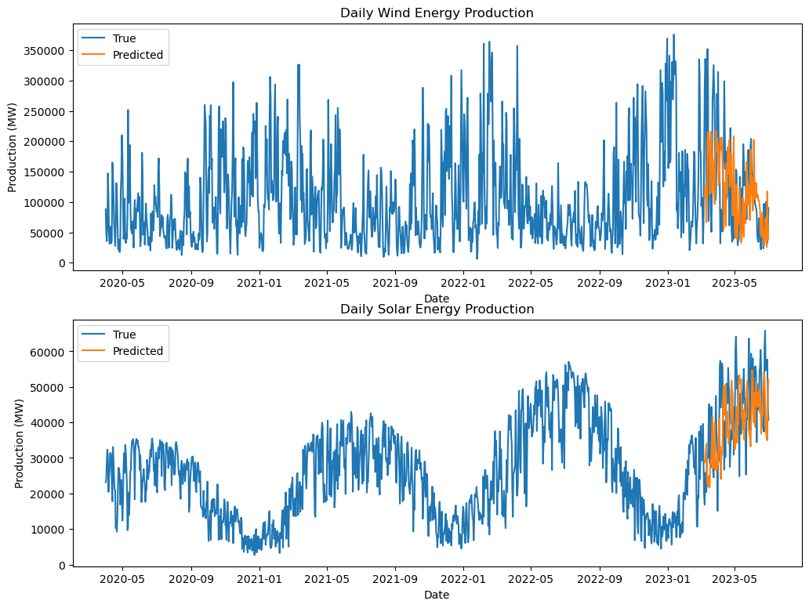

**Fig: Predicted vs Actual Energy production.**

The model successfully predicted solar and wind energy production, demonstrated by visual comparisons between actual and predicted values. During model training, experiments were conducted with batch sizes of 8 and 32, and models were trained over 50 and 300 epochs, respectively. These variations helped fine-tune the model for more accurate forecasting.

To optimize the model's hyperparameters, **Keras Tuner** was employed. This method tested multiple configurations to identify the best-performing hyperparameters, including the number of units, dense layer sizes, dropout rates, and learning rate. The final results from Keras Tuner are as follows:

* **Best validation loss**: 0.0107
* **Elapsed time**: 25 minutes and 9 seconds
* **Best hyperparameters**:
  + Units: 352
  + Dense Units 1: 384
  + Dropout 1: 0.2
  + Dense Units 2: 256
  + Dropout 2: 0.4
  + Learning Rate: 0.00179

This tuning helped significantly reduce validation loss while maintaining accuracy. For example, in one of the key trials:

* **Epoch 0**: Loss = 0.04197 | Accuracy = 25.42%
* **Epoch 50**: Loss = 0.02379 | Accuracy = 36.99%
* **Epoch 100**: Loss = 0.00789 | Accuracy = 54.54%
* **Epoch 150**: Loss = 0.00365 | Accuracy = 68.89%

The model’s performance continually improved with more epochs, and a balance between overfitting and accuracy was struck using regularization techniques such as dropout layers.